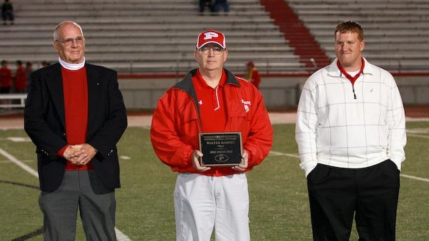
Ash Broadwater II (whose father played on same team with Walter Barnes), Hall of Fame chairman Carroll Jett, Marc Kimes
Barnes, Kimes Enter Grid Hall
The latest inductees into the Parkersburg High School Football Hall of Fame are definitely two of the most famous former Big Reds.
Friday night prior to the start of the Big Reds' homecoming game against Cabell Midland, Walter "Piggy" Barnes and Marc Kimes became the seventh and eighth members to join the Hall of Fame.
In 1971 the Parkersburg Sentinel selected an all-time Mid-Ohio Valley football team and the player named the Greatest Player of All Time was, believe it or not, a tackle. But not an ordinary tackle, a tackle named Walter “Piggy” Barnes. Not only was Barnes one of the best football players to ever wear the Red and White, he was an outstanding college gridder at LSU and later became renowned as a movie actor.
The 6-foot-1, 208 pound Barnes was fast enough to run the 440 in track. He also scored two touchdowns and kicked 19 extra points as a 20-year-old senior in 1938 when the Big Reds went 10-0 and won the state championship.
He was an all-conference college lineman a LSU, playing in the College All-Star game in 1944. He then played pro football for the Philadelphia Eagles of former Parkersburg High School gridder Earl “Greasy” Neale.
Barnes, who reportedly earned his nickname by stealing a pig from a downtown market, then became a movie and TV actor, appearing on shows like Gunsmoke, Rawhide, Cheyenne and movies like Pete’s Dragon and Bronco Billy. He even had a bare-knuckle fight with Clint Eastwood in the climactic scene of the movie “Every Which Way but Loose”.
Marc Kimes’ legacy at Parkersburg High School can be summed up by listing the accomplishments of his team during his three year career as the starting quarterback - two state championships and one state runner-up.
Kimes called the signals for 42 straight Big Red games from 1999 to 2001 and PHS won 38 of those games, including the first team to go 14-0 and came within one game of being a three-time champion.
He scored 200 points in his career and ranked second with 108 of those coming from his talented foot. He threw 52 touchdown passes and finished with 5,320 career yards – both school records. For his career he had 6,171 yards in total offense, over 1,500 more than the second best Big Red player.
As a sophomore he engineered that incredible second round playoff comeback victory over Huntington (rallying from an 18-0 deficit in the fourth quarter) and then guided his team to a state finals win over Riverside.
His junior year ended with a 38-13 loss in the finals to Morgantown but even losing his head coach and two mid-season regular season games could not deter him from taking a second title as a senior with a 28-17 victory over Martinsburg. He was named Most Valuable Player in the championship game in 2001 as well as taking top honors in the MSAC and becoming only the third PHS player to capture the Kennedy Award. He was a two-time all-stater.
He went on to set school records for career and single-season passing yards at West Virginia Wesleyan. He finished as the fifth leading passer of all time in the West Virginia Conference and sixth all-time leader in total offense.
The Hall of Fame is located above the PHS locker room in the Mary Lou Hague Art & Sports Complex (annex) and is open prior to each home game and at various other times.

